./

GENESIS - Mini-project Summary Report-Calculator



|  |  |  |  |  |  |
| --- | --- | --- | --- | --- | --- |
| **Ver. Rel. No.** | **Release Date** | **Prepared. By** | **Reviewed By** | **To be Approved** | **Remarks/Revision Details** |
| 1 | 7/12/2020 | Arjun Joshi |  |  |  |
| 2 | 7/12/2020 | Naveen Kumar Pappuru |  |  |  |
| 3 | 7/12/2020 | Archana G R |  |  |  |
|  |  |  |  |  |  |
|  |  |  |  |  |  |

**Details**

Contents

Contents 3

Mini project – Calculator 4

**1.Introduction** 4

**2. Objectives & Requirements** 4

**2. Design** 6

**3. TEST PLAN** 8

HIGH LEVEL

LOW LEVEL 8

**4. GIT LINK** 9

https://github.com/99003202/MiniProject_Calculator.git 9

**5. Summary** 9

Challenges faced and how were they overcome 9

**LIST OF FIGURES**

*FIGURE 1 COSTING AND AGING OF CALCULATOR WITH AGING……………………………………………….........................4*

*FIGURE 2 CLASS DIAGRAM…………………………………………………………………………………………………………………………….6*

*FIGURE3 COMPONENT DIAGRAM ……………………………………………………………………………………………………………….7*

*FIGURE 4 SEQUENCEDIAGRAM………………….........................................................................................................7*

*FIGURE 5 ACTIVITYDIAGRAM……………………………………………………………………………………………………………………….8*

**LIST OF TABLE**

*TABLE 1 SWOT ANALYSIS……………………………………………………………………………………………………………………………5*

*TABLE 2 INTEGRATED TEST PLAN ……………………………………………………………………………………………………………...8*

*TABLE 3 LOW LEVEL TEST PLAN…………………………………………………………………………………………………………………9*

# Mini project – Calculator

## **1.Introduction**

The project is to build calculator software that performs arithmetic operations on numbers. The simplest calculators can do only addition, subtraction, multiplication, and division. More sophisticated calculators can handle exponential operations, roots, logarithms, trigonometric functions, and hyperbolic functions. Internally, some calculators actually perform all of these functions by repeated processes of addition.

## **2. Objectives & Requirements**

**2.1 Aging and costing**

.

Fig1. Costing and aging of calculator with aging.

**2.2 4W1H**

What?

A calculator is a device to use for the mathematical calculation, which makes work much easier.

When?

When the calculations to be made are complicated and take more time.

Where?

Where the calculations become complex to handle manually.

Why?

To make the complexity of the work less and to save time.

How?

Calculators are made depending on requirement. Different types of calculators are available such as simple calculator, scientific, graphical and printing calculators.

**2.3 SWOT ANALYSIS**

|  |  |
| --- | --- |
| **Strength** | **weakness** |
| * Solve complicated problems * Consumes less time * Inexpensive to maintain | * For scientific calculators it is difficult read user manual. * Small mistakes give the whole answer wrong and needs recheck. * The size of number entered is limited. |
| **Opportunity** | **Threats** |
| * Calculators can be developed further scientifically with less complexities for user. | * Each model of calculator need different instruction sets * Dependency on calculator reduce human analyzation capacity. |

Table1. SWOT Analysis.

## **2. Design**

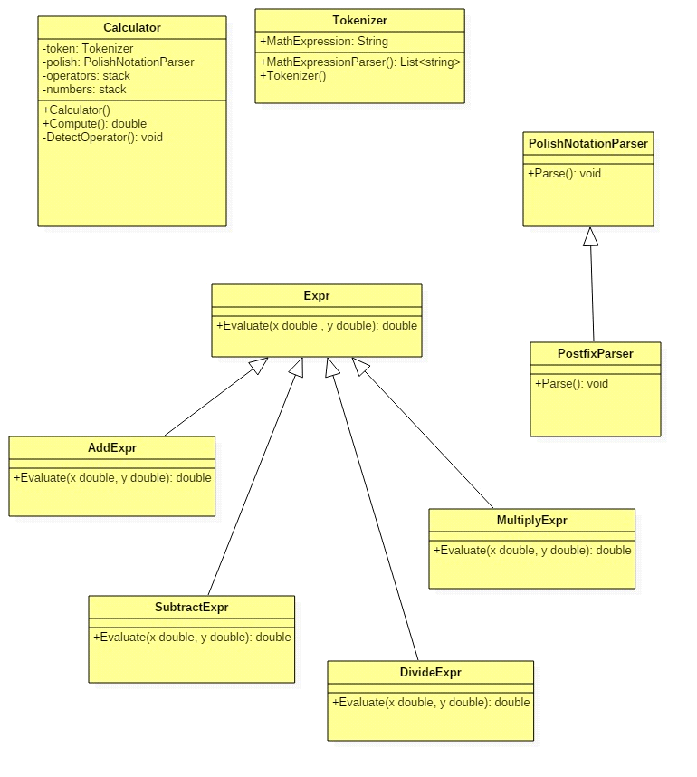

Figure2.Class diagram

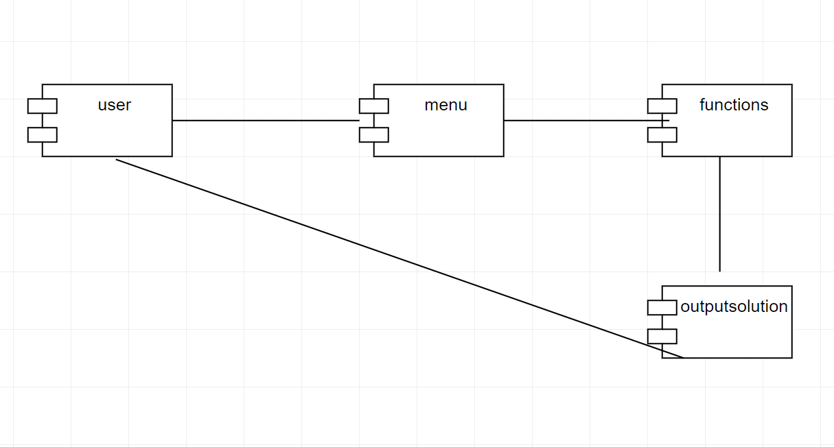

Figure3 Component diagram

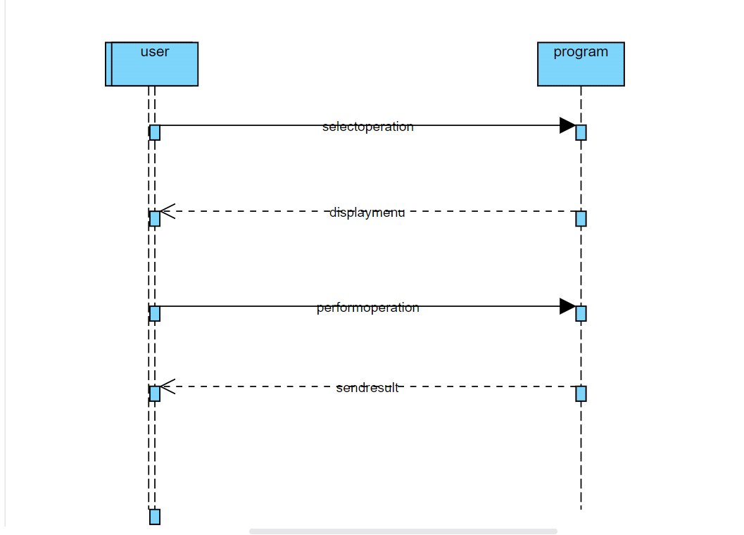

Figure4.sequence diagram

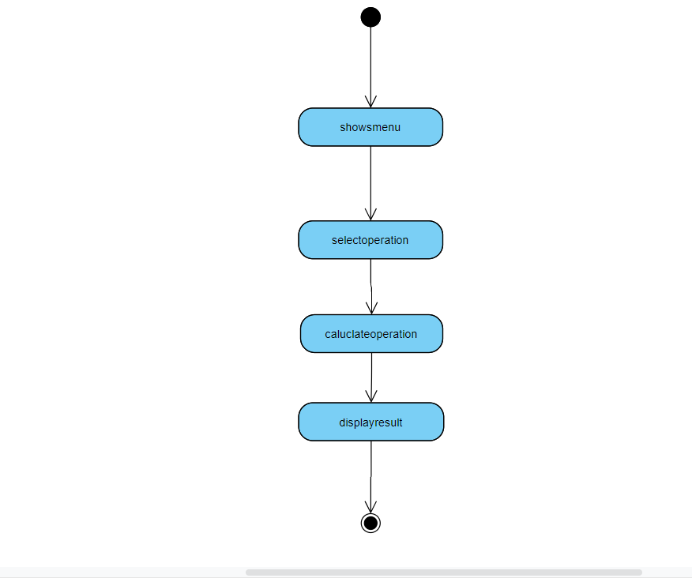

Figure 5 Activity diagram.

## **3. TEST PLAN**

**3.1 INTEGRATION TEST PLAN**

|  |  |  |  |  |  |
| --- | --- | --- | --- | --- | --- |
| **Test ID** | **Test Description** | **Expected Input** | **Expected Output** | **Actual Output** | **Result of the Test** |
| T01H | Taking input | Entered 2 numbers | Entered | Entered | passed |
| T02H | Operation on each function | Function selected | Calculation done and displayed output | Calculation done and displayed output | Passed |
| T03H | Display output | Input entered | Output displayed | Output displayed | Passed |

### Table2. Integrated test plan

### 3.2 LOW LEVEL

|  |  |  |  |  |  |
| --- | --- | --- | --- | --- | --- |
| **Test ID** | **Test Description** | **Expected Input** | **Expected Output** | **Actual Output** | **Result of the Test** |
| T01L | Addition | Enter 2 and 3 | Output is 5 | Output is 5 | Passed |
| T02L | Subtraction | Enter 2 and 1 | Output is 1 | Output is 1 | Passed |
| T03L | Multiplication | Enter 3 and 4 | Output is 12 | Output is 12 | Passed |
| T04L | Division | Enter 6 and 3 | Output is 2 | Output is 2 | Passed |
| T05L | Modulus | Enter 6 and 3 | Output is 0 | Output is 0 | Passed |
| T06L | Square | Enter 2 | Output is 4 | Output is 4 | Passed |
| T07L | Square root | Enter 4 | Output is 2 | Output is 2 | Passed |
| T08L | Kilometers to meters | Enter 1 | Output is 1000 | Output is 1000 | Passed |
| T09L | Meters to centimeters | Enter 1 | Output is 100 | Output is 100 | Passed |
| T10L | Feet to inches | Enter 1 | Output is 12 | Output is 12 | Passed |
| T11L | Inches to centimeters | Enter 1 | Output is 2.54 | Output is 2.54 | Passed |
| T12L | Centimeters to meters | Enter 10 | Output is 0.1 | Output is 0.1 | Passed |
| T13L | Yard to meters | Enter 1 | Output is 0.9144 | Output is 0.9144 | passed |
| T14L | Yard to centimeters | Enter 1 | Output is 91.44 | Output is 91.44 | Passed |
| T15L | Sin function | Sin(90) | Output is 1 | Output is 1 | Passed |
| T16L | Cos function | Cos(90) | Output is 0 | Output is 0 | Passed |
| T17L | Tan function | Tan(0) | Output is 0 | Output is 0 | Passed |
| T18L | Cot function | Cot(0) | Output is infinity | Output is infinity | Passed |
| T19L | Co-secant function | Cosec(90) | Output is 1 | Output is 1 | Passed |
| TT20L | Secant function | Sec(45) | Output is 1.414 | Output is 1.414 | Passed |

Table3. Low level test plan.

### 4. GIT LINK

### <https://github.com/99003202/MiniProject_Calculator.git>

**4.1Git dashboard screenshot**

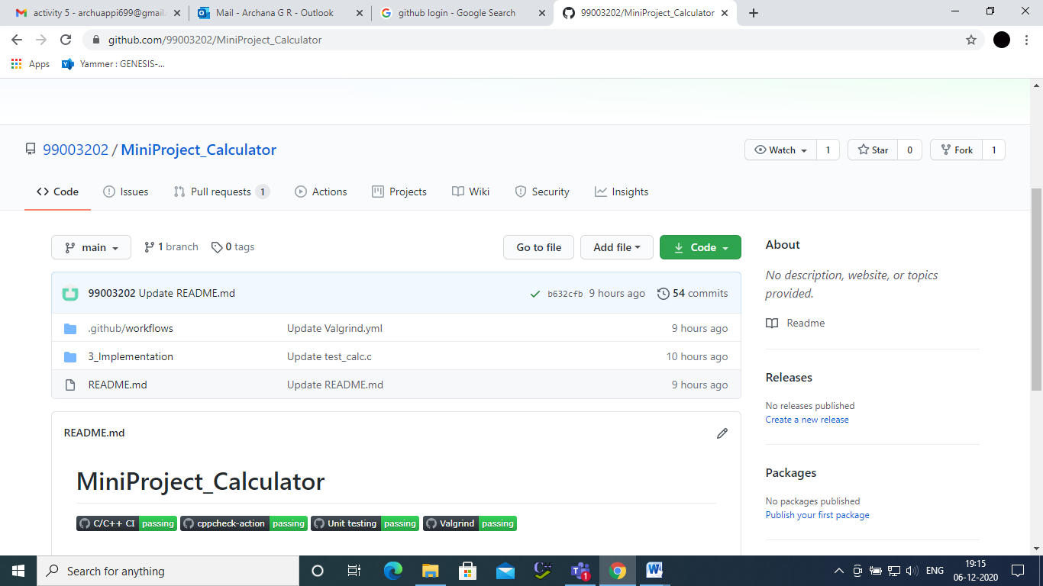

### 

### 5. Summary

The mini project is to build the calculator with Arithmetic functions and conversion functions. The functions which are available for the user are Addition, subtraction, multiplication, division, modulus, squaring of the number, square root. The conversion functions used are kilometers to meter, meters to centimeter, feet to inch, inch to centimeter, centimeters to meter, yard to meter, Yard to centimeters. The tools used for the mini project are Visual studio code, GitHub and Microsoft word for the documentation.

### Challenges faced and how were they overcome

* Faced problem while uploading to GitHub- overcome with the help of team mates.
* Faced problem at the time of installation – overcome by referring to videos given in the yammer.